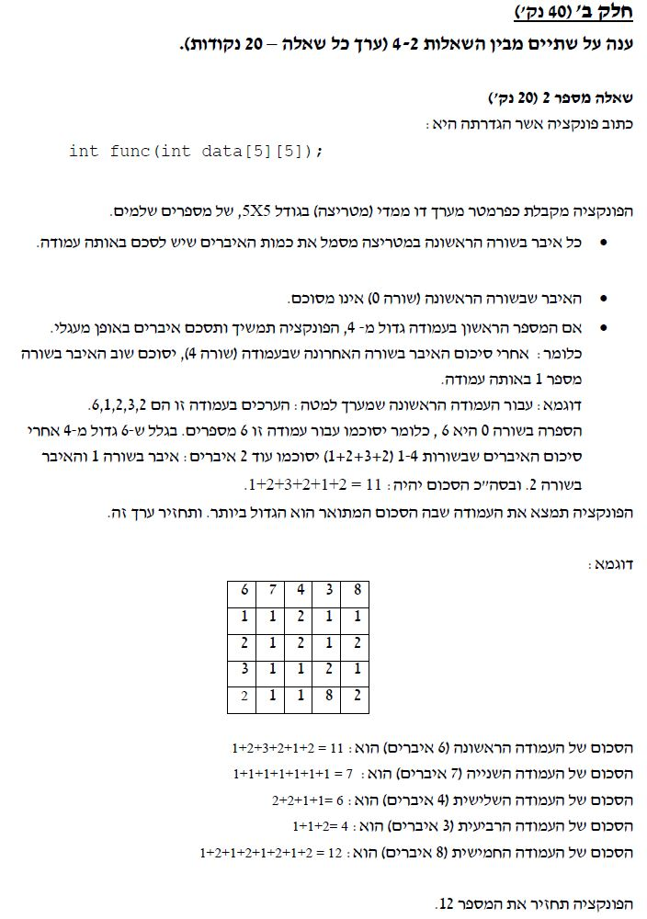

תשובה:

#include<stdio.h>

int func(int data[5][5])

{

int sumCol = 0, maxColSum = 0, indexMaxCol;

int i, j, limit = 4, rounds, mod;

for (i = 0; i < 5; i++)

{

if (data[0][i] <= limit)

{

for (j = 1; j <= data[0][i]; j++)

{

printf("+%d", data[j][i]);

sumCol += data[j][i];

}

}

else

{

rounds = data[0][i] / 4;

mod = data[0][i] % 4;

while (rounds--)

{

for (j = 1; j <= limit; j++)

{

printf("+%d", data[j][i]);

sumCol += data[j][i];

}

}

for (j = 1; j <= mod; j++)

{

printf("+%d", data[j][i]);

sumCol += data[j][i];

}

}

printf("=%d", sumCol);

if (sumCol > maxColSum)

{

maxColSum = sumCol;

indexMaxCol = j;

}

printf("\nMatrix Sum Col %d is %d\n\n", i + 1,

sumCol);

sumCol = 0;

}

return maxColSum;

}

int main()

{

int data[5][5] = { {6,7,4,3,8},{1,1,2,1,1},{2,1,2,1,2},

{3,1,1,2,1},{2,1,1,8,2} };

int i, j, maxColSum;

printf("Matrix[%d][%d]:\n", 5, 5);

for (i = 0; i < 5; i++)

{

for (j = 0; j < 5; j++)

printf("%3d", data[i][j]);

printf("\n");

}

printf("\n");

maxColSum = func(data);

printf("Max Col Sum is %d\n", maxColSum);

getchar();

return 0;

}